Marc Jones – COMP2003 Personal Evaluation:
Introduction:
As a part of this group project, the team and I had to develop a web-based game for our client. We worked under an agile methodology via two-to-three-week sprints. Whilst work for this project was split between each member, I took the role of team leader. I was not appointed this role, but I was the most experienced member of the group when it comes to games development. As such, I was the best fit to know what should happen and when.

Contibutions:
During the period of our sprints, we would first meet with our lecturer to discuss our groups progress. Following this, we would meet amongst ourselves and with our clients. Evidence of the latter two can be found in our GitHub repository (under meeting minutes). I had planned these meetings so also took the responsibility of keeping track of how often they occurred and (briefly) what was covered. This can be seen through the repo history for that file:
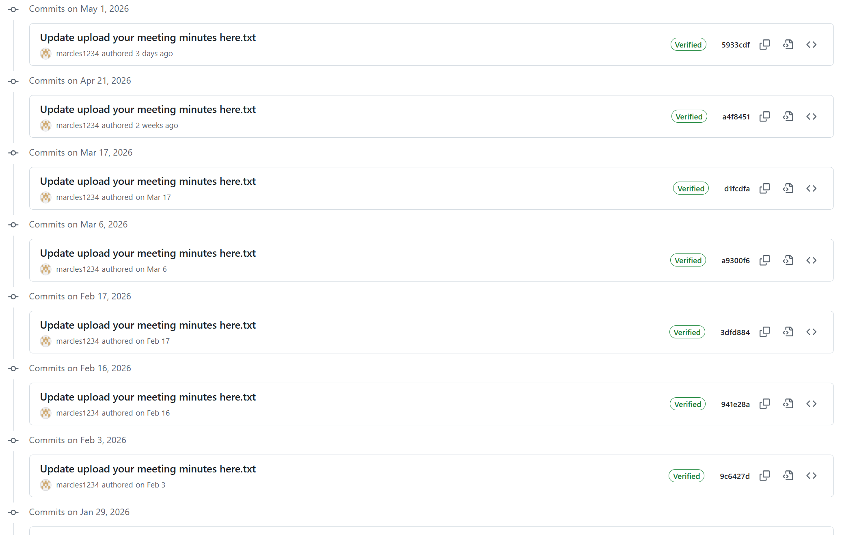
Image 1 – Meeting recording evidence
Moreover, as shown by our Trello board (https://trello.com/b/LVYGkmzm/group-6), you can see that I was the primary manager of creating tasks for our sprints and assigning them to a group member that would agree to do it.
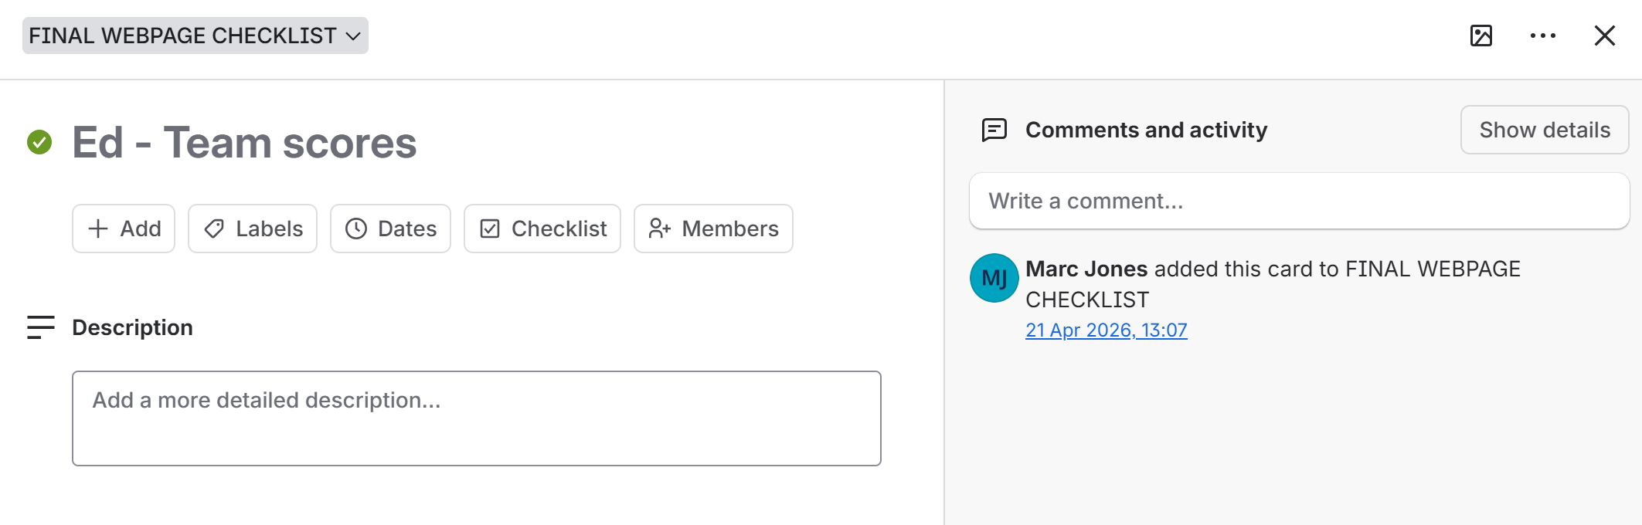
Image 2 – Trello board evidence
With this in mind, I would like to note that I would not do this by myself. I would ask my fellow group mates if they had anything to add and if they felt comfortable with the work assigned to them. Often times, those who don’t feel comfortable with something won’t say it outright. Therefore, it is really important that every member is addressed.
As for development, my largest contribution was the questioning system. We quickly identified that we would like to integrate AI into our website in the form of a question generator. This would allow for a much quicker way of making multiple choice questions.
To implement this, I originally had planned to connect to a AI model directly via an API. Whilst this is a good option and provides a quick and accurate response, I was unable to find any available for free.
So I did some more research. I had come across a website called ‘Hugging Face’ where you could run a model through a virtual machine of sorts. This can then be accessed an API connection. This solution was free but extraordinarily slow and unreliable. It was not fit for use under our non-existent budget (you can pay to access more resources).
I then had a recommendation through an email chain from my lecturer Dr Ji-Jain Chin. I had heard about an application called ‘Ollama’ but would not be sure if this would be a good fit for our website. He helped guide me with my query and offer IT support should I have needed it.
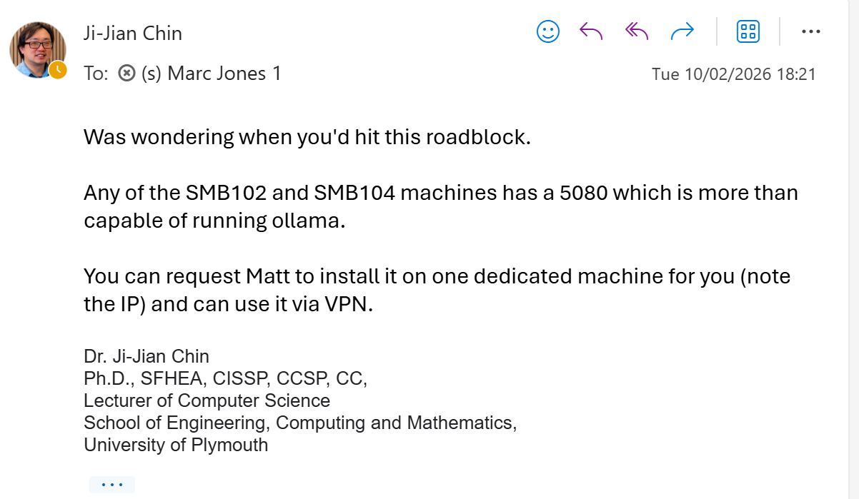
Image 3 – Email evidence
Upon completion of getting AI integration for question generation, I turned my attention to getting these questions into a usable format and into the website itself for anyone to use. This can be seen through my commit history from March 4th – April 27th.
Alongside this AI questioning development, I also helped with:
- Games development. Creating the ‘Jumper’ and ‘Flapper’ games functionality (not asset creation)
- Wireframes and site flow mapping
- Game loop iterations
- Mini games randomisation
- General website cleanup
- Website hosting
On the documentation side of things, I produced:
- Final game concept
- Project proposal
- Client handbook
- Poster for showcase day
- (+ my sections in this final report)

Evaluation of group work:
Overall, I think our group worked together well. Each group member showed up, on time, for each sprint, group and client meetings (unless they had a reasonable excuse). Each group member remained open to communication both in person and not with our shared group chat.
With this being said, I do feel that that the workload could have been onboarded more effectively. Some members of the group have produced slightly more than others and at slightly varying qualities. No group member has been a burden to this project however as everybody has contributed.
Our biggest pitfall has been meeting our sprint meeting quotas. There is no one member of the group that is not guilty of this in some degree. Every sprint meeting we had tended to have slightly underproduced what we had set ourselves up to achieve. Hence, with every sprint finishing, we had slowly fell behind and forced to cram in the last few weeks of the project.

Reflection:
My biggest pitfall has been not reaching out for help when I require it. I had spent a lot of time trail and erroring certain aspects of the project when help and guidance has been readily available. In particular, the AI problem mentioned previously. I had spent almost a week trying to get around the problem before I asked for help. Asking for this help has helped boost my confidence in requesting assistance should I need it.
However, I have really enjoyed working on this project. As stressful as it has been for all, I am pleased with what we have achieved. We have almost hit our original design plan exactly with only small features, visual improvements and cleanups to be made.
This has taught me a lot about working on a computing project as a group. From what makes a good team to version control (GitHub) to client management to general coding and networking knowledge, I have greatly improved in my ability to work on a larger scale project such as this. I really do see the benefits of this project and how it will help me in the computing industry.

